**SULUR**

**HERO**

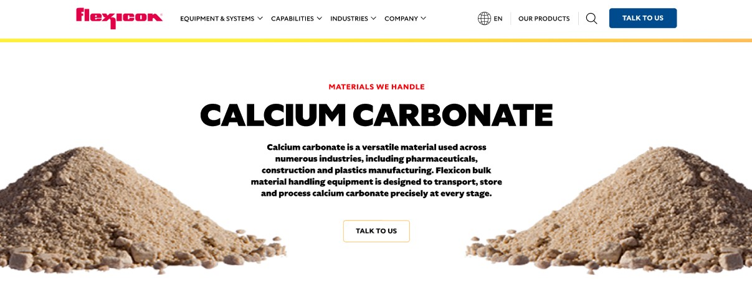

Sulfur is a bright yellow, naturally occurring element used in a wide range of industrial applications. Flexicon bulk material handling systems are engineered to safely and efficiently convey, store, and process sulfur at every stage.

**Button**: Talk To Us

**SHELF #1 - PRODUCT DESCRIPTION**

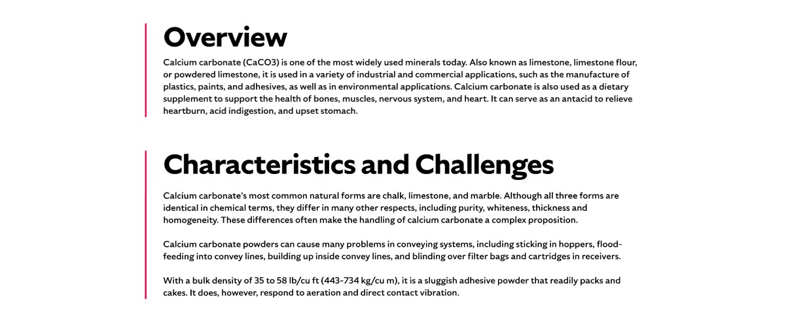

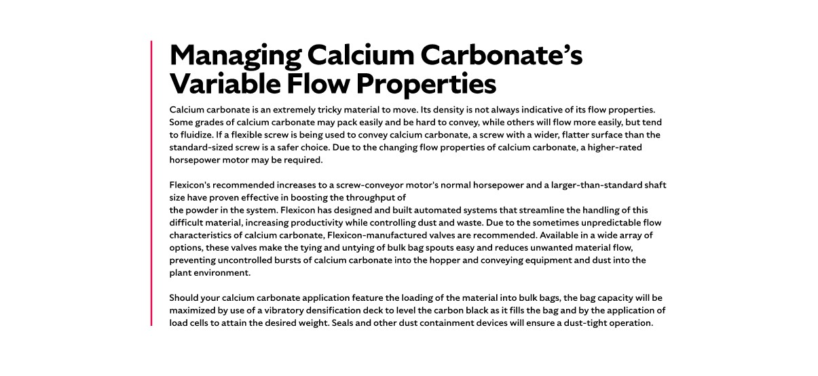

**Overview**

Sulfur plays a vital role in various industries, including fertilizer production, oil refining, wastewater treatment, mineral extraction, rubber vulcanization, and nylon manufacturing. It is also a key component in the production of sulfuric acid, one of the most widely used industrial chemicals. Despite its usefulness, sulfur presents unique handling challenges due to its flammability, abrasiveness, and the potential to release toxic gases when ignited. Proper containment and explosion protection are essential when working with this material. In its pure form, sulfur is odorless; the characteristic smell often associated with it comes from sulfur compounds. Additionally, sulfur is popular among mineral collectors for its bright yellow color and distinctive crystalline shapes.

**Characteristics and Challenges**Sulfur is available in powdered and granular forms, with bulk densities ranging from 45 to 70 lb/cu ft. It is both abrasive and corrosive, requiring durable, corrosion-resistant equipment—typically made from 316 stainless steel. Sulfur dust is highly combustible and poses serious fire and explosion risks, especially when exposed to friction, static electricity, or heat. Strict containment, dust control, and explosion protection measures are essential to ensure safe handling and compliance with safety regulations.

Due to its poor flow characteristics, sulfur can bridge or rat-hole in hoppers, requiring flow-aid devices like vibrators or agitators. Bulk bag dischargers should include accessories such as spring-loaded frames and bag activators to promote complete discharge and minimize operator intervention. Dust collectors and filtration systems are critical to prevent airborne particles during transfer. For manual unloading, bag dump stations with dust control features are recommended, while proper screw design and moisture control are key to maintaining flow in flexible screw and pneumatic conveying systems.

**SHELF #2 - FLEXICON SOLUTIONS**

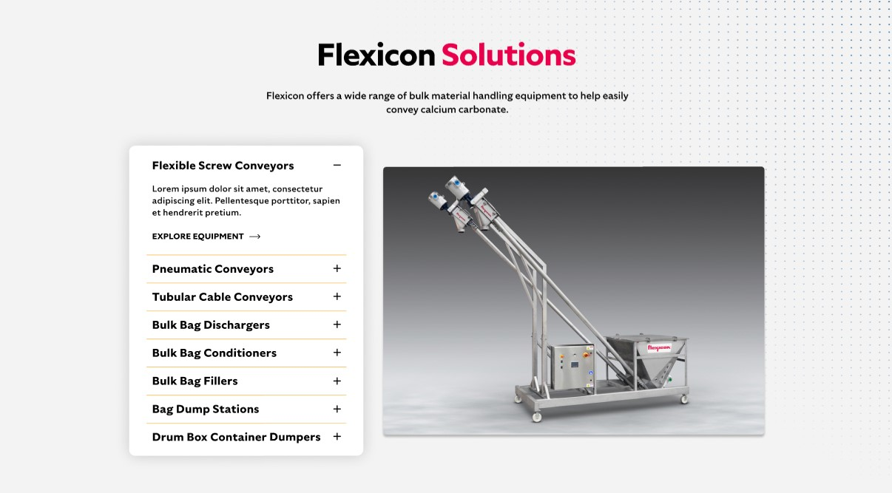

**Flexicon Solutions**

Flexicon offers a wide range of bulk material handling equipment to help easily convey sulfur:

* **Flexible Screw Conveyors:** Designed to move sulfur smoothly while reducing the risk of friction-related heat and airborne dust.
* **Pneumatic Conveyors:** These sealed systems use filtration to safely capture and recycle sulfur dust, helping to prevent combustion hazards.
* **Tubular Cable Conveyors**: Offer a gentle, enclosed conveying method ideal for sulfur, especially in facilities with limited space or complex layouts.
* **Bulk Bag Dischargers**: Provide a secure and dust-controlled way to empty sulfur from bulk bags, with built-in mechanisms to promote complete discharge.
* **Bulk Bag Conditioners:** Apply pressure to compacted sulfur bags to restore flow and ensure consistent material feed into downstream equipment.
* **Bulk Bag Fillers**: Enable precise, dust-minimized filling of sulfur into bulk bags using vibration and sealing technologies for clean, accurate loading.
* **Bag Dump Stations**: Facilitate safe manual unloading of sulfur with integrated dust collection and filtration to protect workers and maintain cleanliness.
* **Drum/Box/Container Dumpers**: Efficiently transfer sulfur from smaller containers into processing systems while reducing manual handling and dust exposure.

**SHELF #3: LIFETIME PERFORMANCE GUARANTEE**

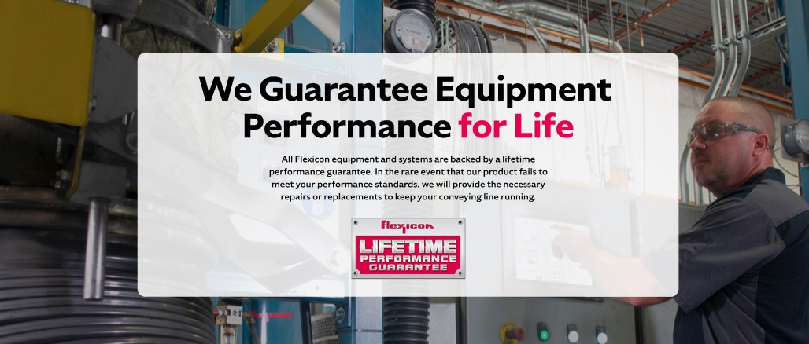

**Lifetime Performance Guarantee**

All Flexicon equipment and systems are backed by a lifetime performance guarantee. In the rare event that our product fails to meet your performance standards, we will provide the necessary repairs or replacements to keep your conveying line running.

**SHELF #4: CASE STUDIES**

